**DATA ANALYST PORTFOLIO PROJECT**

POWER BI + SQL + EXCEL

**ICC WT20 2024 cricket dataset**

**1. Problem Definition**

The primary objective of this project is to analyze the ICC WT20 2024 cricket dataset to extract valuable insights and measure key performance indicators (KPIs). By leveraging advanced data analysis techniques, we aim to create a dynamic, interactive dashboard that can be used to visualize various aspects of the cricket matches, identify trends, and make data-driven decisions. The solution will utilize Excel, SQL Server, Power BI, and Tableau for comprehensive analysis and visualization.

OR//

The goal of this project is to analyze the ICC WT20 2024 cricket dataset to derive valuable insights and measure key performance indicators (KPIs). Using advanced data analysis techniques, the objective is to create a dynamic and interactive dashboard that visualizes various aspects of the cricket matches, identifies trends, and aids in data-driven decision-making. This solution will utilize Excel, SQL Server, Power BI, and Tableau for comprehensive analysis and visualization.

**2. KPIs Requirements**

To evaluate the performance and gain insights, we need to define several KPIs, such as:

1. **Runs Scored per Match**: Total runs scored by each team in every match.

SELECT Match_ID, Country, SUM(Runs_scored) AS Total_Runs

FROM iccwt20_2024

GROUP BY Match_ID, Country;

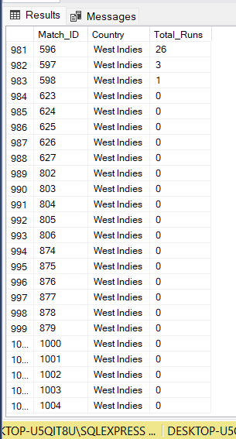

1. **Strike Rate of Batsmen**: Calculation of strike rates for individual batsmen.

SELECT Player,

SUM(Runs_scored) AS Total_Runs,

SUM(Ball_scored) AS Total_Balls,

(SUM(Runs_scored) / SUM(Ball_scored)) * 100 AS Strike_Rate

FROM iccwt20_2024

GROUP BY Player;

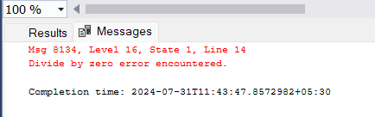

-- AFTER EXCEUTING THIS QUERY GOT ERROR MSG LIKE Msg 8134, Level 16, State 1, Line 14

--Divide by zero error encountered.

--Completion time: 2024-07-31T11:39:18.0688712+05:30

-- players. To avoid this, you can add a condition to ensure that the division only happens when SUM(Ball_scored) is greater than zero. Here’s how you can modify your query:

SELECT Player,

SUM(Runs_scored) AS Total_Runs,

SUM(Ball_scored) AS Total_Balls,

CASE

WHEN SUM(Ball_scored) > 0 THEN (SUM(Runs_scored) / SUM(Ball_scored)) * 100

ELSE 0

END AS Strike_Rate

FROM iccwt20_2024

GROUP BY Player;

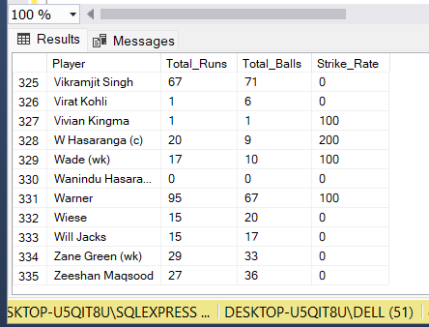

1. **Boundary Count**: Total number of fours and sixes hit by each batsman.
2. -- 3. Boundary Count: Total number of fours and sixes hit by each batsman.

SELECT Player,

SUM(scored_4s) AS Total_Fours,

SUM(scored_6s) AS Total_Sixes

FROM iccwt20_2024

GROUP BY Player;

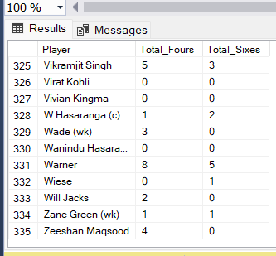

1. **Bowling Economy**: Economy rate of each bowler.

-- 5. Bowling Economy: Economy rate of each bowler.

SELECT Player,

SUM(Runs_Conseded) / SUM(Overs_Conseded) AS Economy_Rate

FROM iccwt20_2024

WHERE Overs_Conseded > 0

GROUP BY Player;

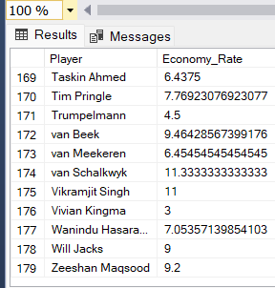

1. **Wickets Taken**: Total number of wickets taken by each bowler.

-- 6. Wickets Taken: Total number of wickets taken by each bowler.

SELECT Player,

SUM(Wickets_Conseded) AS Total_Wickets

FROM iccwt20_2024

GROUP BY Player;

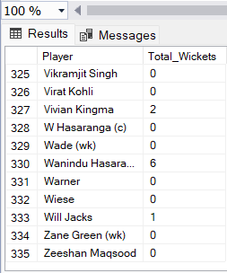

1. **Team Performance**: Comparative analysis of team performances across different venues and times.
2. **Player Performance**: Individual player performance metrics including runs, strike rates, and wickets.
3. **Extras Conceded**: Number of no-balls and wides conceded by bowlers.

SELECT Player,

SUM(NB_Conseded) AS No_Balls,

SUM(WD_Conseded) AS Wides

FROM iccwt20_2024

GROUP BY Player;

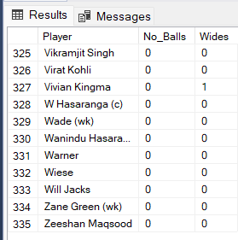

**Additional KPIs**

**Batting Average:**

* **Definition: The average number of runs scored by a batsman per dismissal.**
* **Calculation: Total Runs Scored / Number of Times Dismissed.**

SELECT Player,

SUM(Runs_scored) AS Total_Runs,

COUNT(*) AS Matches_Played,

(SUM(Runs_scored) / COUNT(*)) AS Batting_Average

FROM iccwt20_2024

WHERE Bat_Status LIKE '%b%'

GROUP BY Player;

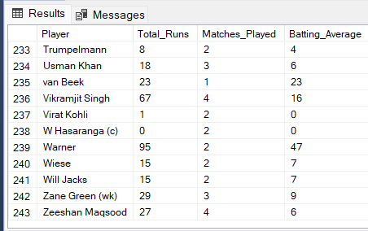

**Bowling Strike Rate:**

* **Definition: The average number of balls bowled per wicket taken.**
* **Calculation: Total Balls Bowled / Total Wickets Taken.**

SELECT Player,

SUM(Ball_scored) AS Total_Balls_Bowled,

SUM(Wickets_Conseded) AS Total_Wickets,

(SUM(Ball_scored) / SUM(Wickets_Conseded)) AS Bowling_Strike_Rate

FROM iccwt20_2024

WHERE Wickets_Conseded > 0

GROUP BY Player;

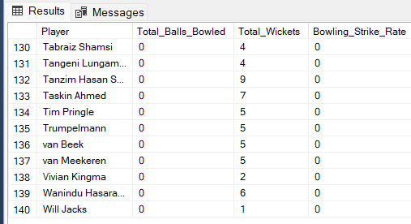

**Catches Taken:**

* **Definition: Total number of catches taken by a fielder.**

SELECT Player,

COUNT(*) AS Catches_Taken

FROM iccwt20_2024

WHERE Bat_Status LIKE 'c %'

GROUP BY Player;

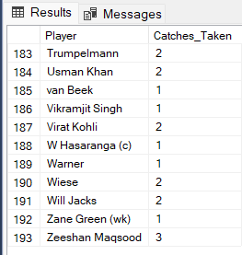

**Partnership Runs:**

* **Definition: Total runs scored in partnerships between batsmen.**

SELECT Match_ID,

Country,

SUM(Runs_scored) AS Partnership_Runs

FROM iccwt20_2024

GROUP BY Match_ID, Country;

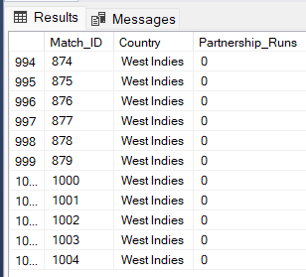

**Dot Balls Bowled:**

* **Definition: Total number of deliveries bowled without conceding any runs.**

SELECT Player,

SUM(CASE WHEN Runs_Conseded = 0 THEN 1 ELSE 0 END) AS Dot_Balls_Bowled

FROM iccwt20_2024

GROUP BY Player;

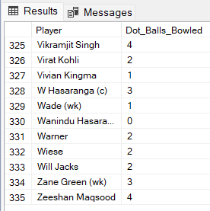

**• Match Winning Performances:**

* **Definition: Individual performances that significantly contributed to the team's victory (subjective, usually based on key match stats).**
* **Calculation: Can be a composite KPI considering runs, wickets, economy rate, and match result.**

**• Consistency Index:**

* **Definition: Measure of consistency in performance (e.g., standard deviation of runs scored across matches).**

SELECT Player,

STDEV(Runs_scored) AS Consistency_Index

FROM iccwt20_2024

GROUP BY Player;

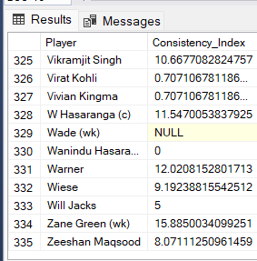

**Powerplay Performance:**

* **Definition: Team performance during the powerplay overs (first 6 overs in T20).**
* **Calculation: Runs scored and wickets lost during powerplay overs.**

**Death Overs Performance**:

* **Definition**: Team performance during the death overs (last 4 overs in T20).
* **Calculation**: Runs scored and wickets lost during death overs.

**Contribution to Team Total:**

* **Definition: Percentage contribution of an individual player's score to the team's total score.**
* **Calculation: (Player's Runs Scored / Team's Total Runs) * 100.**

SELECT Player,

SUM(Runs_scored) AS Player_Runs,

(SUM(Runs_scored) / (SELECT SUM(Runs_scored) FROM iccwt20_2024 WHERE Country = 'Team' AND Match_ID = cs.Match_ID)) * 100 AS Contribution_Percentage

FROM iccwt20_2024 cs

GROUP BY Player, Match_ID;

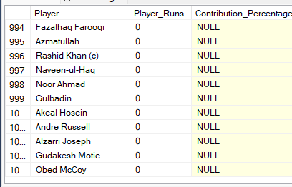

**4. Charts Requirement**

To visualize the dataset and gain insights, the following charts and visualizations are recommended:

1. **Runs Scored per Match**: Bar chart showing the total runs scored by each team in every match.

SELECT Match_ID,

Country,

SUM(Runs_scored) AS Total_Runs

FROM iccwt20_2024

GROUP BY Match_ID, Country

ORDER BY Match_ID, Country;

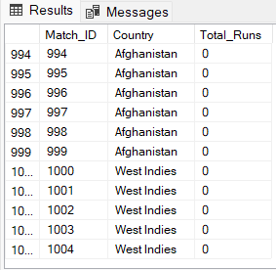

1. **Player Strike Rate**: Scatter plot or bar chart depicting the strike rates of individual players.
2. **Boundary Count**: Stacked bar chart showing the total number of fours and sixes hit by each player.

SELECT Player,

SUM(scored_4s) AS Total_Fours,

SUM(scored_6s) AS Total_Sixes

FROM iccwt20_2024

GROUP BY Player

ORDER BY Player;

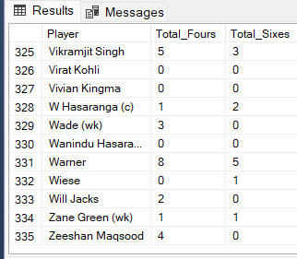

1. **Bowling Economy Rate**: Line chart or bar chart showing the economy rate of each bowler.

--4. Bowling Economy Rate: Line chart or bar chart showing the economy rate of each bowler.

SELECT Player,

SUM(Runs_Conseded) AS Total_Runs_Conceded,

SUM(Overs_Conseded) AS Total_Overs,

(SUM(Runs_Conseded) / SUM(Overs_Conseded)) AS Economy_Rate

FROM iccwt20_2024

WHERE Overs_Conseded > 0

GROUP BY Player

ORDER BY Economy_Rate;

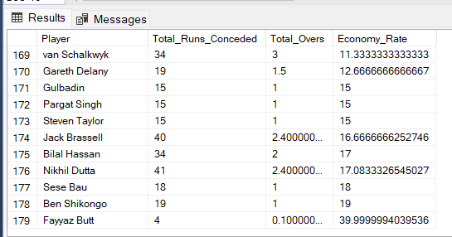

1. **Wickets Taken**: Bar chart representing the total wickets taken by each bowler.

SELECT Player,

SUM(Wickets_Conseded) AS Total_Wickets

FROM iccwt20_2024

GROUP BY Player

ORDER BY Total_Wickets DESC;

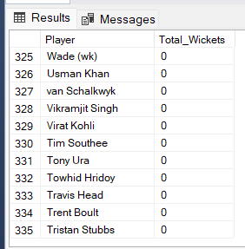

1. **Team Performance by Venue**: Heatmap or grouped bar chart showing team performance metrics across different venues.

SELECT Venue,

Country,

SUM(Runs_scored) AS Total_Runs,

SUM(Wickets_Conseded) AS Total_Wickets

FROM iccwt20_2024

GROUP BY Venue, Country

ORDER BY Venue, Country;

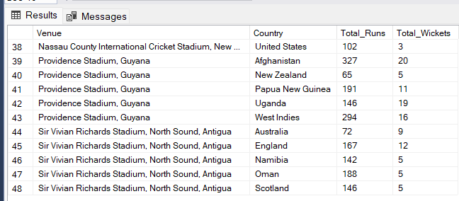

1. **Extras Conceded**: Bar chart showing the number of no-balls and wides conceded by each bowler.

SELECT Player,

SUM(NB_Conseded) AS No_Balls,

SUM(WD_Conseded) AS Wides

FROM iccwt20_2024

GROUP BY Player

ORDER BY Player;

